

Customer Portal User Guide

Contents

Instructions for ABS Customer to add themselves as an Authorised Contact on the Advantage Customer Portal 1

Navigation Around the Portal Home Page 5

Instructions for Creating a New Support Case 7

How to Review Cases and Add a Portal Note 11

Using Knowledge Base Articles 13

# Instructions for ABS Customer to add themselves as an Authorised Contact on the Advantage Customer Portal

**This will allow you to log into the Portal, Log/View/Edit Support cases relating to your Dynamics Applications and view Knowledge Base Articles for self-help purposes.**

1. The first step is to add the free Microsoft App called Microsoft Authenticator to your mobile phone. Make sure you add the correct Microsoft App. It’s easy to choose other non-Microsoft ones which won’t work.

[Download and install the Microsoft Authenticator app - Microsoft Support](https://support.microsoft.com/en-gb/account-billing/download-and-install-the-microsoft-authenticator-app-351498fc-850a-45da-b7b6-27e523b8702a)

1. You will receive this invitation by email. Please open it and click on ‘Accept invitation’



1. This webpage will open – Click on ‘Accept’

1. The Advantage Portal will open. To login, please click on the ‘Sign in’ button

1. Next click on the Azure AD button (You have already been added to Advantage’s Azure Environment as a guest)

1. Select the email account to which the invitation email was sent and proceed through your Multifactor Authentication Process

If you haven’t already Added Microsoft Authenticatoe App to you Phone you will be promted to do so

Scan the relevant code on your mobile to take you to the app to install

Login into the Microsoft Authenticator using you Microsoft Account.

You can click on the cross at the top right of the App and Choose to Add a Work or School Account

and then you can the scan the QR code which you will be given via the Portal or you can enter the code manually if you are having trouble scanning the ABS QR code. This created ABS as an Account in the Authenticatoe App.

You will be give a 2 digit code in the Portal which you enter in the Microsoft Authenticator App and then you are finished with this set and will be able to use this App for the MFA code to be entered when you sign into the Portal, going forward

1. After MFA has been completed, you will be taken to your profile page on the first time you log into the Portal and you can update your contact details. Please take a moment to ensure these details are correct and add all relevant information eg Job Title phone numbers etc Please then click on ‘Update’.

1. You are ready to start Logging/Viewing and Editing Dynamics Support Cases!

***Important Note:***

***Dynamics Support Cases comprise Break/Fix Support Issues. Please refer any Systems Administration, Training or System Change Requests to your Advantage Account Manager by email. This way, you will not waste one of your organisation’s annual support cases.***

# Navigation Around the Portal Home Page

At the top of the screen you can process, view and edit cases via the **Case Tab,** peruse our library of **Knowledge Bases Article**, use the Search icon to find cases and articles and also **Login** or Logout – On this screen shot the logged in username is displayed but if you are not logged in, the Tab is displayed as **‘Login’**

**Hyperlinks** are available for **User Instructions** for the Portal and Advantage **Training Courses** on the Advantage website.

If you scroll down, you have links to various Knowledge Base Articles

And scroll down further still to for various ‘**Get Help’** Options

# Instructions for Creating a New Support Case

***Important Note:***

***Only log you Dynamics Support Cases here. If you query relates to our Managed Service Centre (eg we host your servers and or manage your IT systems, please email*** [***ticket@advantage.co.uk***](mailto:ticket@advantage.co.uk)***.***

***If your request relates to Dynamics System Administration, Training needs or System Change Requests, please refer this to your Account Manager.***

***Logging request like this here, will use up your annual Dynamics support case allocation unnecessarily.***

You will need to be logged in to create a case, otherwise you will not see the Cases icon or you will get a permissions error is you try to use the Create Case button at the bottom of the screen. Once you are logged in, the Cases Tab at the top of the screen will be enabled.

Click here and you will open this screen:

Click on the turquoise ‘+ Create’ button to start a new Support Case.

The Title should describe the problem with detail of the company/user/transaction details.

Your **Customer Contact** details and **Customer Account** will default into the case record.

Add your **Internal Reference** number eg if you log cases via your own IT Helpdesk with its own case reference system, to allow a cross reference.

The **Entitlement** field refers to your organisation’s Dynamics Support Contract – This will default in unless you have more than one eg you might have Dynamics BC and Dynamics CRM Support with us.

***Please note that your Managed Services Cases are logged via an email to*** [***ticket@advantage.co.uk***](mailto:ticket@advantage.co.uk)

You will need to select the **Product** in order for the case to be directed to the correct team of Support consultants.

Select the Relevant **Case Type**

Choose the relevant **Priority** of the case

An **Additional Contact** can be added to the case – You will be able to select from the contacts of which your organisation has previously advised us. If you cannot see them in the list, please add their name, job title, phone number and email address to the body of the case and we can add it in for you after you have submitted the case.

**Case Description**

We have pre-entered a list of the required information to allow the support team to proceed with resolving the case. Without this information the resolution of the case is likely to be stalled until it has been provided, so please be sure to provide each piece. All the text is editable. Example responses are below:

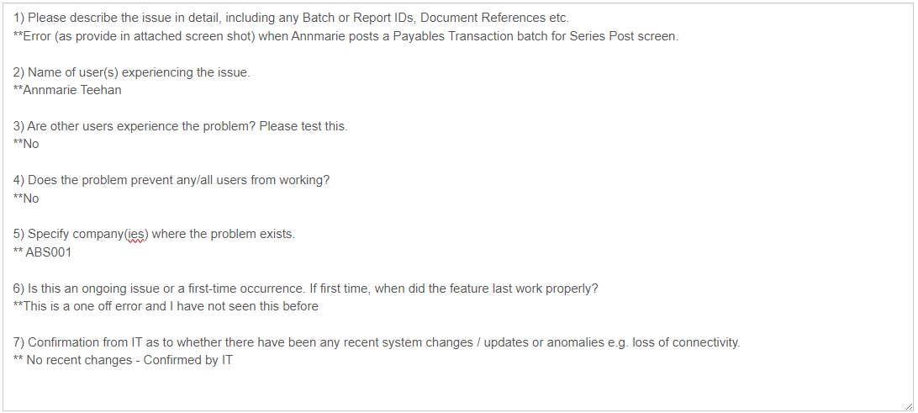

Unfortunately you can not add screen shots into the Case Description, so please paste them into a document and attached below via the ‘Choose Files’ button and then click on ‘Submit’ once you a happy with all the case details.

Wait a moment and you will get confirmation that the case has been created.



You and the additional contact will receive a **case acknowledgment** email from a no reply Support email address. There will be a hyperlink back to the case on the Portal should you need to add additional information. If you are not logged into the Portal, just click on the Sign In Tab again and go to Cases. It will be there.

Your call will be placed, immediately, in Support queue for the relevant Dynamics Team, the case will be triaged and a specialist in that area will contact you to begin the resolution. All correspondence is undertaken via **Portal Comments** but you will also receive an email whenever we add a Portal Comment so you know, instantly, what advice has been given /request for additional information or a remote session asked for.

# How to Review Cases and Add a Portal Note

***Important Note:***

***You make be able to find the solution to your issue by searching and viewing the resolution on a previously Resolved Case. This will save you down time and wasting your annual case allocation of cases, by solving the issue internally rather than escalating to ABS Support.***

Login to the Portal via the Login Tab

Click on the Cases Tab

As a default. you will only see your active cases but you can use the Toggle at the top left had corner to view Resolved or Cancelled Cases too.

You can also use the Search Icon to find cases by parts of the description or case number. Use an asterix in front the of the word or number you want to search on, otherwise it will be looking the full text or number and might not find anything.

Click on the Case Title to open the record.

To ‘Add Comment/Attachment’ to the case click on the turquoise button and ‘Submit’. This will update your case on the Advantage Support CRM system and you will see the comment or the case Timeline.

When Advantage responds, via a Portal Comment, you will get notification of their response via a noreply email. Please note that you will not be able to reply to the email. Instead, please respond via the Portal Comments in the Case Timeline.

**Note:** You can still add Portal Comments to closed cases and Support will be made aware of them but it is usually better to add a new case and cross reference to the old, so that we can both have better visibility if the problem is a recurring one.

# Using Knowledge Base Articles

Advantage are building a library of Knowledge Base Articles (KBAs). This comprises of Frequently Asked Support Questions and general ‘How To’ information.

Please be aware that this is library currently still being developed for content.

To find articles, you can either use the black Search icon in the top tool bar, choose Knowledge Base and enter your text (No asterix needed)

You’ll have a list of potential KBAs returned like this:

You can also search based on topics. To do this, click on the Knowledge Base Tab at the top of the Home screen.



Or click on the button at the bottom.

Choose the Product Line you have you wish to view KBAs for

Select the related Category.

And open any KBAs from the list provided. Some will be document and other will link to videos and webinars.